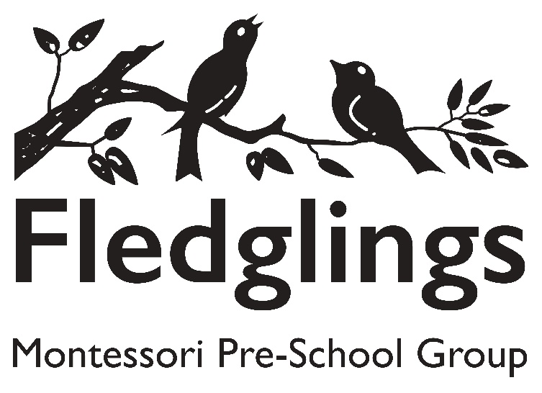

SUSTAINABILITY AND CLIMATE CHANGE POLICY
Sustainability is an essential and integral part of our daily routines at Fledglings Montessori preschool. We wish to instil an understanding and awareness of the importance of sustainable practices, reducing our carbon footprint and impact on the planet. Our commitment to sustainability aligns with the government’s goals to become a net zero nation. By using this resource, we are not only teaching children about the importance of sustainable living but also contributing to a larger movement towards a sustainable future.
“Through their learned and lived experiences from early years to further and higher education; we will provide opportunities to develop a broad knowledge and understanding of the importance of nature, sustainability and the causes and impact of climate change and to translate this knowledge into positive action and solutions. “ DfE Sustainability and climate change a strategy for the education and children’s services systems, 2023

Our Values and Ethos
Our goal is to ensure that our setting and its practices, both inside and out, support sustainability, in line with government expectations regarding sustainability and climate change.
We do our best to reflect these values and our ethos regarding sustainability in everything we do. This includes our consumption of food, energy, and water as well as how we travel and waste reduction or disposal.

Our Curriculum
Providing our learners with a curriculum that teaches them the importance of sustainability and how to live a more sustainable lifestyle is integral to the ethos and values of our setting. Within our curriculum, we will give our learners the following opportunities to extend their understanding and appreciation of sustainability:
- Introduce basic climate and nature themes into storytelling, puppetry, roleplay, small world, Knowledge & Understanding of the World (Nature table) and circle times for example, caring for the planet & the Sea, caring for animals, lifecycles of plants & animals, seasons & weather, recycling.
- Celebrate key environmental dates such as Earth Day and World Oceans Day
- Explore planting and gardening opportunities using containers or raised beds for growing and taking care of fruit and vegetables, in our outside area.
- Provide outdoor learning and play that connects children with nature such as our bug hotel, bug hunts using magnifying glass & bug spotting sheet, birdwatching using binoculars and bird observation sheet.

Food Management
To ensure that we meet sustainability expectations relating to the management of food within activities and mealtimes, the following actions will be taken:
- Introduce recycling bins and teach children about separating waste, for example any packaging (paper/plastic) in their packed lunches, or food waste.
- Encourage staff to estimate and prepare appropriate amount of food required at snack time in line with number of children registered daily, to ensure less food wastage.

Energy
To reduce our environmental impact, our setting aims to, where possible, monitor and limit our energy consumption (electricity and gas). The following actions have been implemented to demonstrate our commitment to this goal:
- Recommend to Landlord to switch to LED lighting, and encourage natural light and ventilation, where possible.
- Turn off ceiling and wall lights when not required or room not in use
- Turn off and unplug electrical appliances when not in use.

We ensure that all learners and staff are informed of the importance of adopting sustainable practices regarding energy consumption. For example, keeping windows closed in colder temperatures and turning off electrical equipment when it is not in use.
We will suggest to the Landlord a smart meter to be installed in line with the government’s recommendations. This will enable us to keep track of our energy usage. Data gathered from the smart meter will identify potential actions to reduce our energy consumption.

Water
We understand that water is a valuable natural resource and that using it wisely and sparingly is essential. To reduce our water consumption within the setting and in our outdoor provision, the following actions have been implemented to demonstrate our commitment to this goal:
- To teach the children the importance of always turning off taps whilst brushing teeth, and after handwashing.
- Children to bring into preschool a named refillable water bottle which they can drink from throughout the session.
- Staff to be encouraged to only fill kettles and washing up bowls with water as required, rather than excess.
- Use water from outdoor water play to water plants, at the end of the session.

Transport and travel
We will endeavour to promote sustainable practices relating to transport and travel.
Our efforts in this area include initiatives to encourage all to travel via more sustainable, environmentally friendly means, including walking, cycling, scootering and (when necessary) public transport. This will enable our setting to reduce its carbon footprint and decrease the number of vehicles on the roads. To further reduce the impact of transport and travel on the environment, we will also do the following:
- If driving is necessary for staff, we encourage carpooling to reduce the number of cars on the road, therefore cutting emissions.
- Where possible, we will support local, visit local markets with the children to support the community and reduce the impact of long-distance supply chains.

Waste Reduction/Disposal
We are committed to reducing the amount of waste we produce as a setting and to disposing of it as much as possible in an eco-friendly way to avoid unnecessarily sending waste to landfills. To ensure that we can limit the amount of waste generated in our setting, we aim to instil proactive sustainability practices in our learners and staff to ensure that, wherever possible, materials are recycled and repurposed.
We will endeavour to:
- Encourage the children and staff to bring reusable water bottles and food containers to reduce single-use plastic waste at the destination.
- Minimise paper waste by using digital resources where possible, promoting a digital-first approach to information sharing.
- Use eco-friendly cleaning products and supplies where possible.
- Encourage reuse and upcycling in craft and play, such as junk modelling using cardboard and bottle tops.
To further our commitment, we ensure that, where possible, our setting sources and uses sustainable, reusable materials and products. This will enable us to contribute to reducing single-use items and ensuring that items are not disposed of in landfills.

Other Actions Within Our Setting
To demonstrate our continued commitment to improving our setting’s sustainable practices, the following additional actions will also be taken:
- Set up a Mini Eco Committee (with staff and children’s voice involved, for example in choosing eco books or garden tasks).
- Share eco tips and updates with parents via email/MMC online app.
- Invite local visitors (such as gardeners, wildlife groups) to speak or engage with the children.
- Partner with local green groups and organise a community green week/clean-up with families.
- Integrate environmental learning into local trips (such as the local park) by discussing the importance of protecting natural habitats and sustainable practices. Teach respect for nature, supporting principles like Leave No Trace.
Our setting will be used to promote the benefits of living sustainably. Instilling such procedures into our daily routines will enable our values and ethos to be put into practice and help us meet our goals, ensuring that our consumption is reduced for the benefit of all. We hope that staff, learners, and their families will also join us in our commitment to protecting the planet.
Last updated September 25

