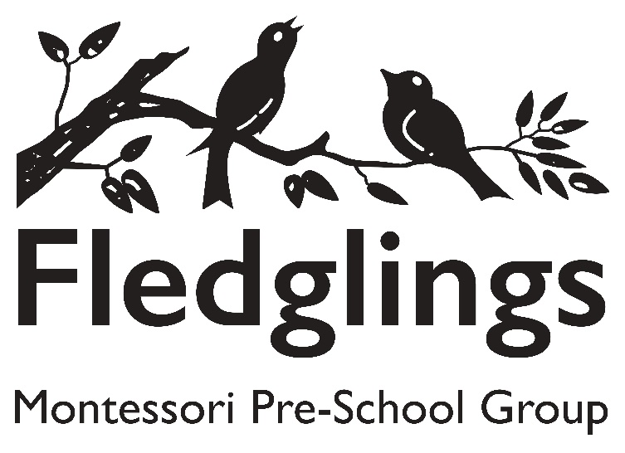
🌍 Preschool Climate Action Plan
Setting Name: Fledglings Montessori Preschool, Bromley
Date of Plan: July 2025
Based on: DfE Sustainability and Climate Change Strategy
Review Date: July 2026

🧭 Vision and Commitment
We are committed to embedding sustainability and climate awareness into our early years practice. Our goal is to foster a love for nature, introduce eco-conscious habits early, and reduce our environmental impact through education and practical action.

1. Leadership and Climate Education
DfE Focus: Increase knowledge and awareness of sustainability and climate change.
Actions:
- Nominate a Sustainability Lead, Emma Brewer (responsible for overseeing green initiatives).
- Include sustainability in the preschool's ethos and mission statement.
- Introduce basic climate and nature themes into storytelling, play, and circle time (e.g. caring for animals, seasons, recycling).
- Provide staff with access to CPD on sustainability in early years (e.g. via online courses or webinars).
- Celebrate key environmental dates (e.g. Earth Day, World Environment Day, World Oceans Day).

2. Greener Settings and Operations
DfE Focus: Improve the environmental sustainability of buildings and operations.
Actions:
- Conduct a mini sustainability audit (e.g. check energy use, water consumption, and waste practices).
- Switch to LED lighting and encourage natural light and ventilation.
- Use eco-friendly cleaning products and supplies where possible.
- Introduce recycling bins and teach children about separating waste.
- Reduce paper usage with more digital communication to parents.
- Explore gardening opportunities using containers or raised beds for growing fruit/veg.

3. Pupil Engagement and Empowerment
DfE Focus: Empower children to be agents of change.
Actions:
- Set up a Mini Eco Committee (with staff and children’s voice involved in some way, like choosing eco books or garden tasks).
- Provide outdoor play and learning that connects children with nature (e.g. bug hunts, weather observation, planting).
- Encourage reuse and upcycling in craft and play (e.g. cardboard boxes, bottle tops).
- Use storytelling and puppetry to introduce climate and care themes in an age-appropriate way.

4. Resilience and Adaptation
DfE Focus: Prepare for and respond to climate-related risks.
Actions:
- Conduct risk assessments for extreme weather (heatwaves, heavy rain).
- Ensure shaded play areas and hydration plans for hot weather.
- Review policies for indoor air quality and ventilation.
- Maintain a plan for emergency closures or disruptions related to climate (e.g. floods).

5. Influence and Partnerships
DfE Focus: Work with parents, the community, and partners.
Actions:
- Share eco tips and updates with parents via newsletters.
- Invite local visitors (e.g. gardeners, wildlife groups) to speak or engage with the children.
- Partner with local green groups or allotments.
- Organise a community clean-up day or green week with families.

📊 Monitoring and Evaluation
- Termly reviews of sustainability actions by the Sustainability Lead, Emma Brewer.
- Feedback forms for staff and parents on eco initiatives.
- Photo displays and learning journals to document children’s eco learning.

📌 Key Targets by July 2026
Goal | Target | By When
Reduce waste | Set up recycling system and reduce landfill waste by 30% | Jan 2026
Outdoor learning | Ensure 3 outdoor nature-based sessions per week | Ongoing
Eco literacy | Introduce 12 climate/nature-themed books into curriculum | Dec 2025
Green space | Establish preschool vegetable or pollinator garden | April 2026

